# Swing User Interfaces

## Overview

In this lab, you will take a basic Swing application and add some UI components to it (such as buttons, text fields, and labels). You will also add code to handle "action" events when the user clicks buttons on the window.

## Source folders

Student project: StudentSwingUI

Solution project: SolutionSwingUI

## Roadmap

There are 3 exercises in this lab, of which the last exercise is "if time permits". Here is a brief summary of the tasks you will perform in each exercise; more detailed instructions follow later:

1. Creating UI components
2. Handling button click events
3. Additional suggestions

## Familiarization with the solution application

Open the *solution* project. The project contains a single class named MemoMinder. Run this class, and you should see the following Swing frame appear:

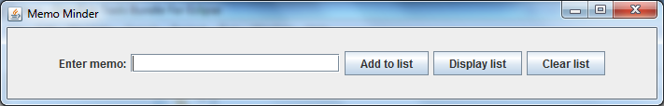

The purpose of the application is to allow the user to keep a list of memos, like a "todo list". Type something into the text box, such as "Watch the football on Saturday" and then click the *Add to list* button. The application adds the memo to a list in memory, and displays a message box to let you know the item has been added safely:

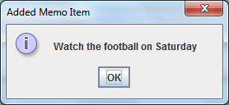

Click OK to close this message box. Back in the main window, add some more memo items, and then click the *Display list* button. The application displays a message box listing all the items added so far. For example:

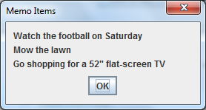

Click OK to close this message box. Back in the main window, click the *Clear list* button. The application clears the list of items and displays a message box confirming this fact:

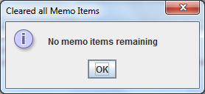

Click OK to close this message box, and then close the main window as well.

## Exercise 1: Creating UI components

Switch to the *student* project and open the MemoMinder class. We've written some of the boilerplate code to get you started. Take a look through this code and make sure you're happy with it as it stands.

Add UI components to the frame window, as indicated by the TODO comments in the code:

* Near the top of the class, declare the Swing UI components. You'll need a label, a text field, and three buttons.
* Inside the MemoMinder constructor, add each of these components to the content pane for the frame window.

Run the application. The frame window should appear as per the solution application, but none of the buttons do anything yet…

## Exercise 2: Handling button click events

In this exercise, you'll add code to handle click events for the 3 buttons in the window.

In Swing, button clicks are "action events", and you handle them by implementing the ActionListener interface. Therefore, modify the MemoMinder class definition so that it implements ActionListener.

To listen for action events on a button, you must invoke addActionListener() on the button. Do this for each of the 3 buttons, where indicated by the TODO comment in the MemoMinder constructor.

When a button is clicked, the actionPerformed() method is invoked on the event-handler object. Therefore, add an actionPerformed() method in your MemoMinder class, and implement it as follows:

* First, call getSource() on the ActionEvent parameter, to determine the source of the event (i.e. which button was clicked).
* If the *Add to list* button was clicked, call the doAddToList() helper method. You'll need to add some code to the doAddToList() method, to get the text entered by the user and add it to the list of memo items. See the comments in the code for guidance.
* If the *Display list* button was clicked, call the doDisplayList() helper method. You'll need to add a bit of code to this method too, to display the list in a message box.
* If the *Clear list* button was clicked, call the doClearList() helper method. You can add a bit of code to this method as well, if you like, to let the user know the list has been cleared.

Run the application again. You should now find that all of the buttons work as expected.

## Exercise 3 (If time permits): Additional suggestions

* After the user has clicked one of the buttons, clear the text in the text box, and put the cursor back in the text box ready for the user to enter another memo.
* Disable the *Display list* and *Clear list* buttons if there are no items in the list.